As we have learned the forest ecosystem is very important. Many factors affect the forest, both human and natural factors. Some of these factors help the forest (enhance it), while others harm the growth of the forest (threaten it).
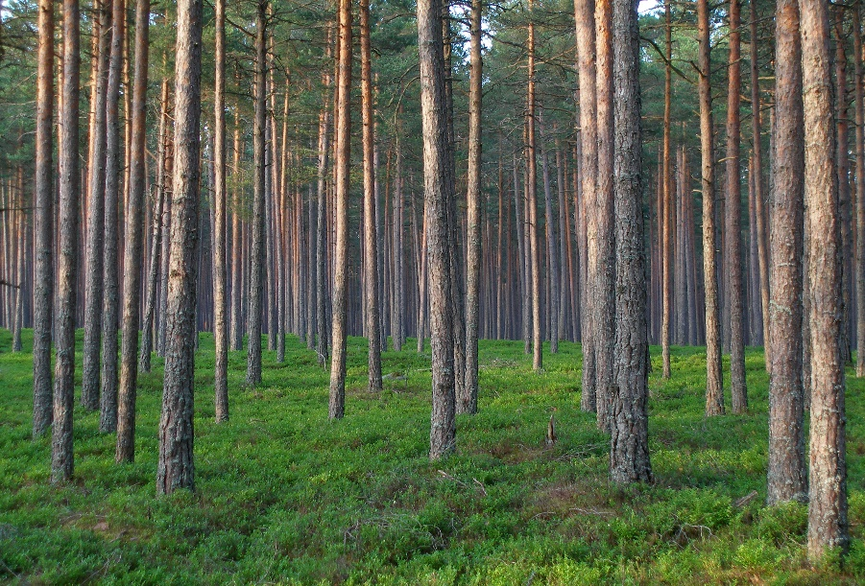
Choose a topic to research:
- National Forests
- Logging
- Insects
- Forest Fires
- Types of Harvesting

Research how the above factor may enhance and/or threaten the forest.
(*Most of these have both positive and negative effects on the forest.)

Create a poster to display your information, be sure to include:
- Pictures that represent your topic
- Information explaining your topic
- A chart (pro/con) that shows both positive and negative effects on the forest.

Finally, when you have finished your poster please reflect on the following questions. You may either write a written reflection or tell me your thoughts verbally. (Give 2 powerful reasons)
- Why is the forest ecosystem important to human beings, animals, and life in general?
- In what ways are humans threatening the forest ecosystem? (Give 2 powerful ways)
- In what ways are humans enhancing the forest ecosystem? (Give 2 powerful ways)

